Assignment

NOTE: Do not forget to see manual page using "--help" option in command when searching for options/commands for a particular task.

1. Install Docker, either on your native OS or on a VM. Make sure it runs. Type "docker -v" to check if it's installed.

If you can't install or configure Docker, you can use the online docker setup to do the assignment.

Step1 Goto:- https://www.katacoda.com/courses/kubernetes/playground

Step2 Click on "continue" button on the left panel

Step3 Click on "launch.sh" button on the left panel

Step4 From the right panel use the top console to execute below command:-

docker -v

Try below commands for help

docker --help ---> This command shows all available options and commands to work with images and containers

docker image --help ---> This command shows all the avaialble options and commands to work with docker images

docker container --help ---> This command shows all the avaialble options and commands to work with docker containers

NOTE:- DO NOT TRY TO USE INTERNET TO SOLVE ASSIGNMENT, BETTER USE THE ABOVE --help OPTION TO SEE THE MANUAL OF ANY PARTICULAR COMMAND AND FIGURE OUT THE SOLUTIONS ON YOUR OWN.

2. Find a image from dockerhub of your choice(recommeded: nginx), don't use browser, pull the official image from dockerhub

Ans:

Docker pull nginx

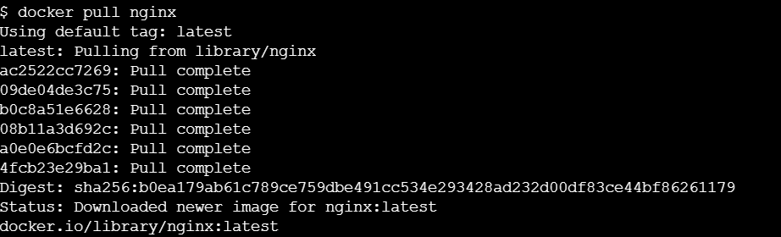

3. List all the available images in your machine/vm, make sure you see recently pulled image in the list.

Ans:

Docker images

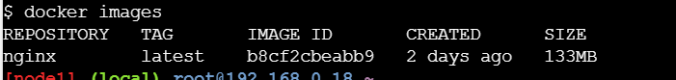

4. Find out the "Full" ImageId of the image that you pulled and write it below.

Ans:

B8cf2cbeabb9

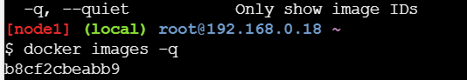

5. Create a container of your image

Ans:



6. List all the running containers

Ans

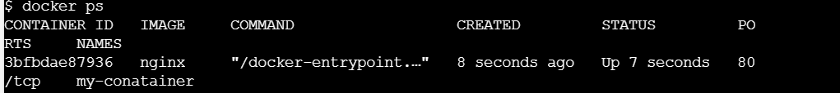

7. List all the running and stopped containers

Ans;



8. Find out the "Full" containerId of the container and write it below.

Ans:



9. Find out how many image layers are used to build this image.

Ans:

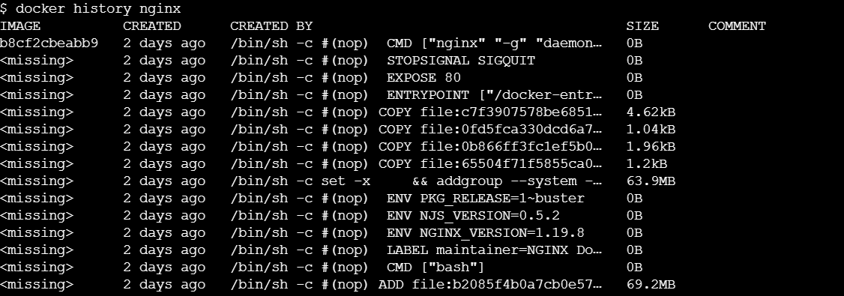

10. Get the Apache Tomcat 7 server image from the docker hub.

Ans:

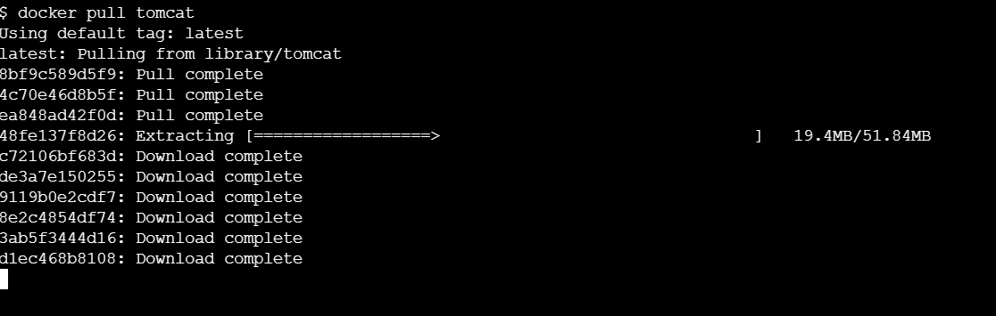

11. Run the Apache Tomcat 7, I mean create a container of Apache Tomcat.

Ans: docker pull tomcat:7

12. Find out what is the IP Address of the Apache Tomcat Container that it is running on

Ans: docker inspect MyTomcat -172.20.0.4

13. Which Port it is using?

Ans:8080

14. Try to access the Tomcat's home page from your machine/vm.

Ans:HTTP ERROR 404

15. What is the disk size of Apache Tomcat image?

Ans: 40kb

16. Find out list of all environment variables that is configured for tomcat image, can you see JAVA_HOME and CATALINA_HOME? What did you notice about it?

Ans: docker inspect MyTomcat

17. Find out which port is exposed for tomcat?

Ans : docker inspect MyTomcat-8080

18. Run multiple conntainers of tomcat on different port and access it's home page.

Ans : docker run -it --name MyTomcat --rm -p 8081:8080 tomcat:7.0

docker run -it --name MyTomcat --rm -p 8082:8080 tomcat:7.0

19. Pull ubuntu os from dockerhub, try to pull 2 images of ubuntu, Except the latest one.

Ans: docker pull ubuntu:20.04

docker pull ubuntu:18.04

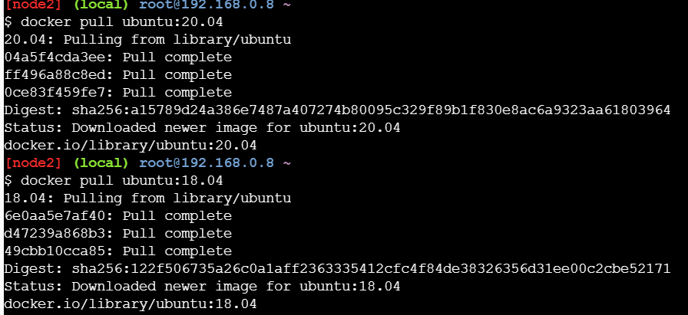

20. Run the container of ubuntu in attached mode.

Ans: docker run -it --name ubuntu20 8e428cff54c8

21. Run the container of another ubuntu in detached mode.

Ans: docker run -it -d --name ubuntu18 3339fde08fc3

22. Check how many ubuntu containers are running and stopped

Ans: docker ps -a

23. Is the tomcat container running? If no, start one.

Ans: docker run -it --name MyTomcat --rm -p 9090:8080 tomcat:7.0

24. Check the logs, generated by tomcat container(don't forget to make request to tomcat's home page to see the log).

Ans: docker logs MyTomcat

25. Check if ubuntu conatiner is running? If no, start one in attached mode to the terminal.

Ans: docker run -it --name ubuntu16 3339fde08fc3

26. Login as root user in ubuntu container

Ans: sudo -s

27. Create a file with any name in root directory

Ans: touch a

28. Install software of your choice in ubuntu container using "apt-get install"

Ans: apt-get -y install sudo

29. Now exit the ubuntu shell, are you back to your host machine, if not, come back to the host machine.

Ans:exit

30. Check if the ubuntu container is running.

Ans: docker ps

31. Create a new ubuntu container out of the same image as that previous container in attached mode.

Ans: docker run -it --name myubuntu1 3339fde08fc3

32. Login as a root user

Ans: sudo -s

33. Check if you can see the file created in previous container, you will not see the file as well as software that you installed in the previous container. Now kill this Container.

Ans: ls

34. Do you have the previous ubuntu container where you created the file and installed the software? If no reapeat step 25 to 29.

Ans: done

35. Create an Image out of the existing container.

Ans: docker commit 7dc7a14c6482 imgcontainer

36. Now Create a Container out of this image and login into it to see if you can see the file and software installed by you in the previous container.

Ans: docker run -it -p 091829a52e94

37. Do you have running tomcat container? If yes, Stop it and kill all tomcat container.

Ans: docker stop my_container

38. Create an index.html file with following code in it:-

<h1>This is Tomcat Container</h1>

Now, Start a tomcat container in such a way that on hitting its URL for home page it should show the above html page.

39. type below command:-

docker images –help

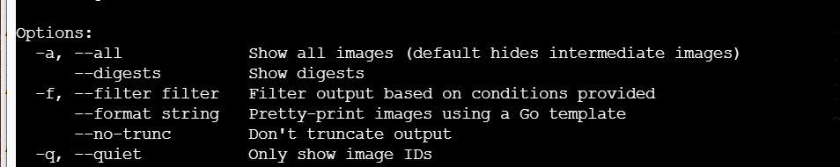

Now, try to run command that proves the concept of following three options:-

1. –a
2. 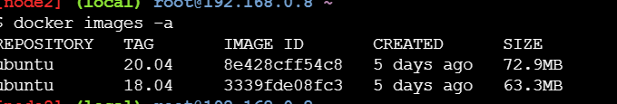
3. –f

3. –q

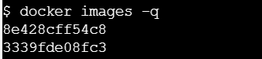

write atleast 1 command using each option above and prove their concepts as described in the --help.

40. type below command:-

docker ps --help

Now, try to run command that proves the concept of following six options:-

1. -a

2. -f

3. -q

4. -n

5. -l

6. -s

